Managing Stress through Mindfulness & Meditation Group

Curious about Wondering what all the meditation? fuss is about?

Take charge of the stress you experience using simple and effective strategies.

Feel calm and empowered rather than tense and overwhelmed.

Join us for this weekly group on Thursdays from 7:00-8:00pm
19 Spear Rd. Suite 301, Ramsey, NJ.
Open to adults.
Call (201) 488-6678 or email intake@specializedtherapy.com
to learn more or register
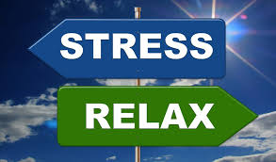

Facilitated by Anna Sandbank, LCSW
Director of Integrative Mind-Body Health
Fx Med Centers, Specialized Therapy Associates, Xceptional You

